**South Indian Wedding Jewelry Online: Explore, Wishlist, and Shop (EC2, Dynamodb)**

**Project Description:**

Sri Anandha Jewelers has elevated its digital strategy by launching a cloud-powered Virtual Jewelry Exhibition and E-Commerce Platform, tailored exclusively for showcasing South Indian wedding jewelry. Hosted on Amazon EC2 and integrated with AWS DynamoDB, the platform provides a rich, immersive online experience where users can explore curated jewelry collections, save favorite items, and engage with interactive features.

A standout component is the Jewelry Quiz, which educates users on traditional designs while offering the opportunity to earn discount coupons. These coupons are securely stored in DynamoDB under each user’s profile and can be redeemed at checkout. The platform also features a Wishlist, a Shopping Cart, and a secure Checkout system, making it a complete e-commerce website.

With a user-friendly interface built using Flask, and AWS services handling backend scalability and data storage, this platform ensures a seamless, personalized, and rewarding shopping journey for customers across the globe.

**Scenario 1: Virtual Jewelry Exploration and Wishlist**A user logs in to the Sri Anandha Jewelers platform hosted on Amazon EC2. While exploring the stunning South Indian wedding jewelry collection, they come across a traditional *Kasu Mala* necklace and add it to their Wishlist. The action is recorded in DynamoDB, linking the item securely to the user’s profile. This enables the user to revisit and manage their Wishlist at any time, aiding in future purchase decisions.

**Scenario 2: Participating in the Jewelry Quiz**After exploring the exhibition, the user participates in the Jewelry Quiz, answering questions related to the cultural significance and styles of South Indian bridal jewelry. Upon successful completion, the user earns a 10% discount coupon, which is automatically saved to their profile in DynamoDB. The coupon appears on the user's dashboard and is also sent via email, ready for redemption.

#### Scenario 3: Adding Wishlist Items to Cart and Purchasing with Coupon

#### Excited by the quiz reward, the user returns to their Wishlist and moves the saved *Kasu Mala* necklace to their Shopping Cart. They proceed to Checkout, where the earned discount coupon is automatically applied to their purchase. The entire

#### 

#### shopping and discount application process is securely handled using data stored in DynamoDB, completing a full-cycle e-commerce experience.

AWS ARCHITECTURE

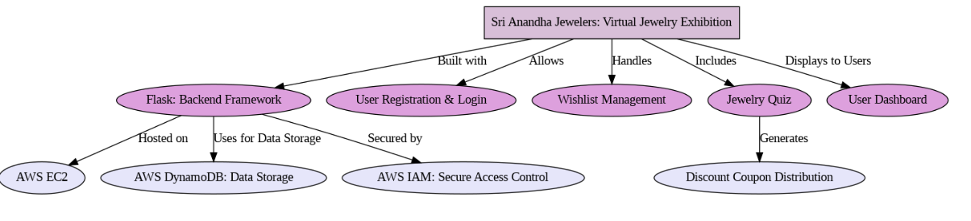

Entity Relationship (ER)Diagram:

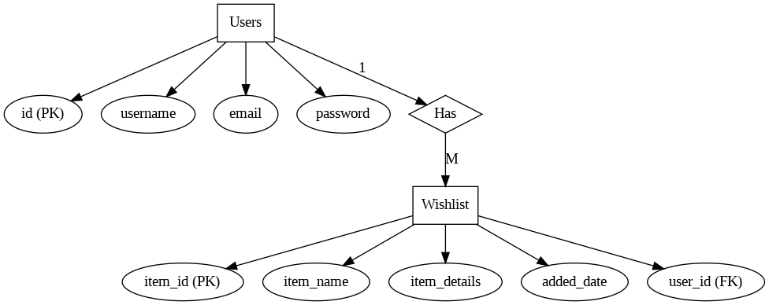

**Pre-requisites:**

### AWS Account Setup: [AWS Account Setup](https://youtu.be/CjKhQoYeR4Q?si=ui8Bvk_M4FfVM-Dh)

### Understanding IAM: [IAM Overview](https://youtu.be/gsgdAyGhV0o?si=3qg-bULgkD4LXNvR)

### Amazon EC2 Basics: [EC2 Tutorial](https://youtu.be/8TlukLu11Yo?si=MUj0nEAOESRhHUIz)

### DynamoDB for Data Management: [DynamoDB Basics](https://docs.aws.amazon.com/dynamodb)

### Git for Version Control: [Git Documentation](https://git-scm.com/doc)

**Project WorkFlow:**

### 1. AWS Account Setup and Login

**Activity 1.1**: Set up an AWS account if not already done.

**Activity 1.2**: Log in to the AWS Management Console

#### 2. DynamoDB Database Creation and Setup

**Activity 2.1**: Create DynamoDB Tables

#### 3. Backend Development and Application Setup

**Activity 3.1**: Develop the Backend Using Flask

#### 4. IAM Role Setup

**Activity 4.1:** Create an IAM Role for EC2

#### 6. EC2 Instance Setup

**Activity 6.1**: Launch an EC2 instance to host the Flask application.

**Activity 6.2**: Configure security groups for HTTP, and SSH access.

#### 7. Testing and Final Deployment

**Activity 7.1**:Data Storage

**Milestone 1: AWS Account Setup and Login**

* **Activity 1.1: Set up an AWS Account**
  + Sign up for an AWS account and configure billing settings.

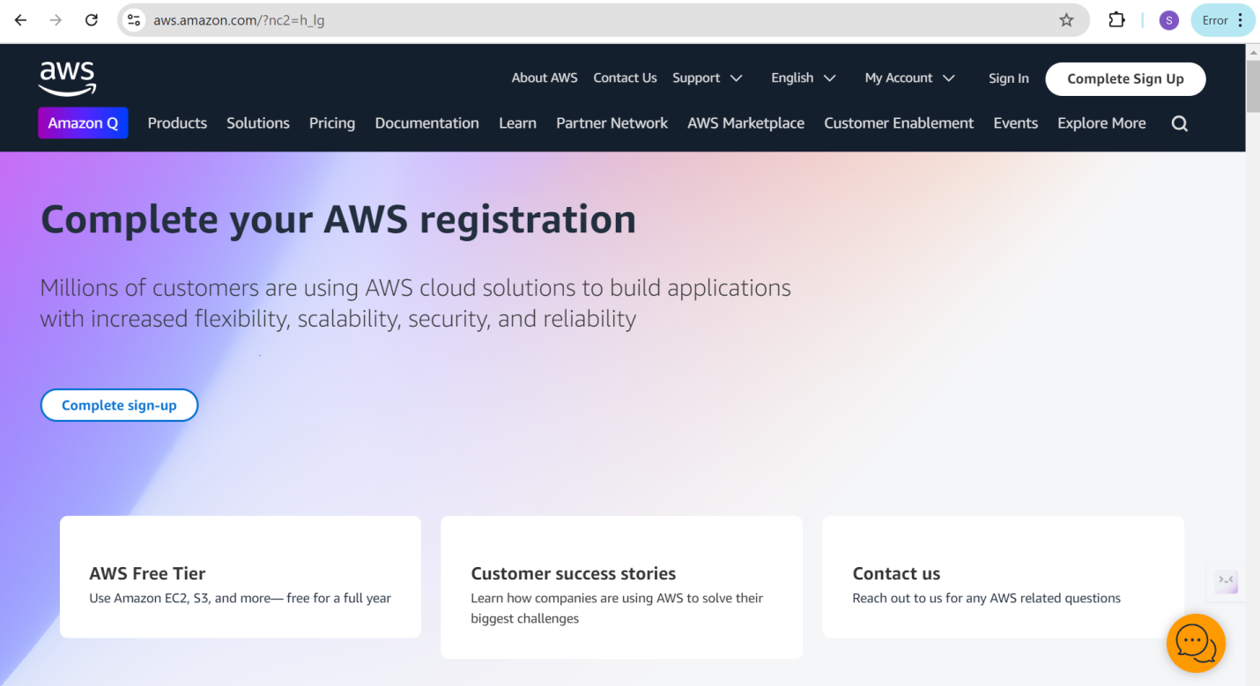

* **Activity 1.2: Log in to the AWS Management Console**
  + After setting up your account, log in to the [AWS Management Console](https://aws.amazon.com/console/).

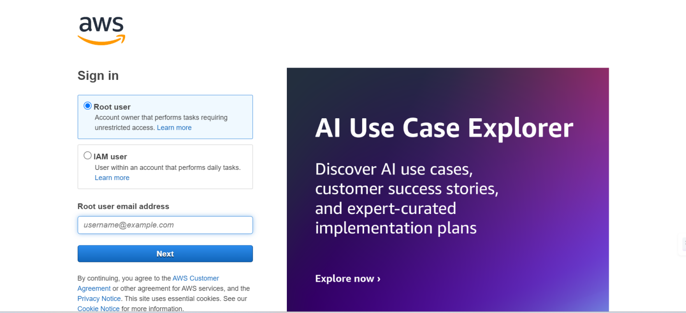

**Milestone 2: DynamoDB Database Creation and Setup**

* **Activity 2.1: Create DynamoDB Tables**
  + In the AWS Console, search for DynamoDB and create a new table to store user data, including registration details, wishlists, and quiz results.

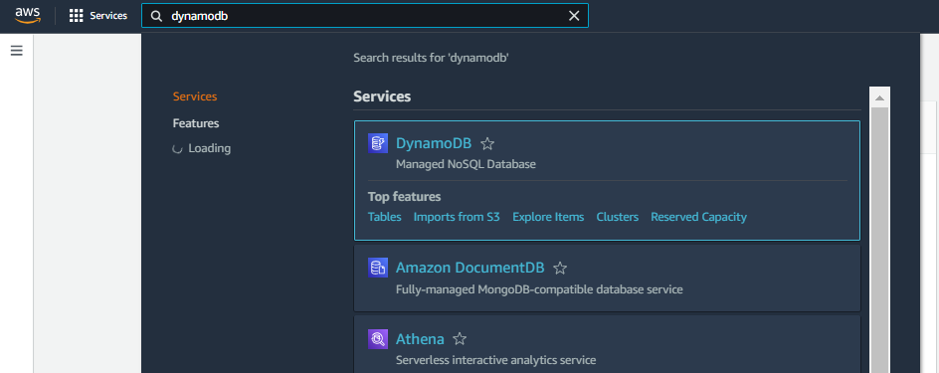

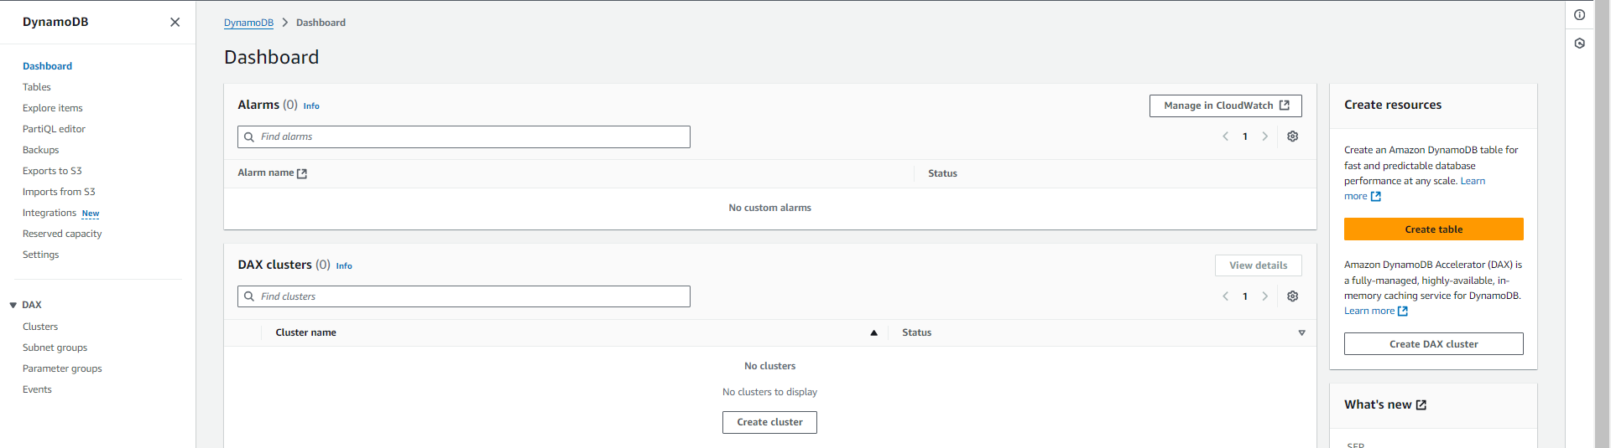

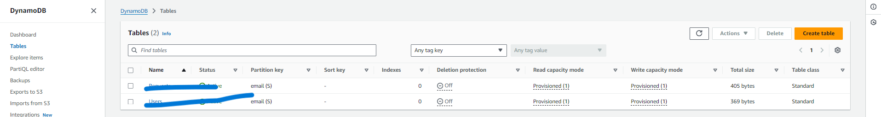

* + For the **User Table**, set email as the **primary key** to store user registration details such as username, email, and password (hashed).

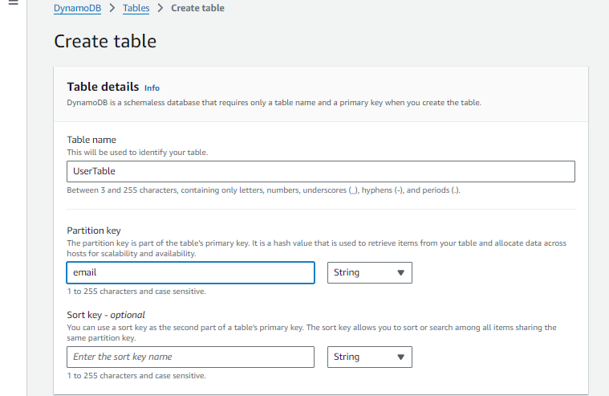

Click on create table.

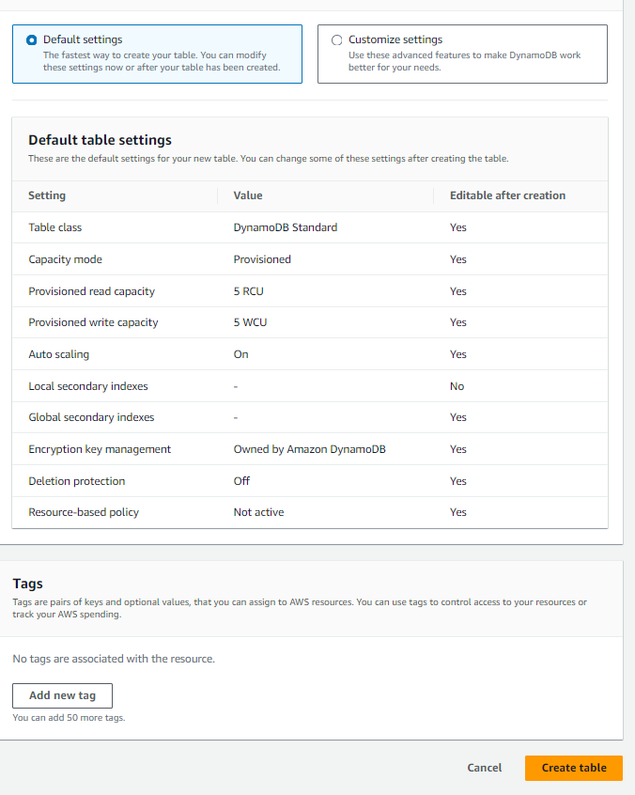

* + For the **Wishlist Table**, define email as the **primary key** and include item_id as Sort key.

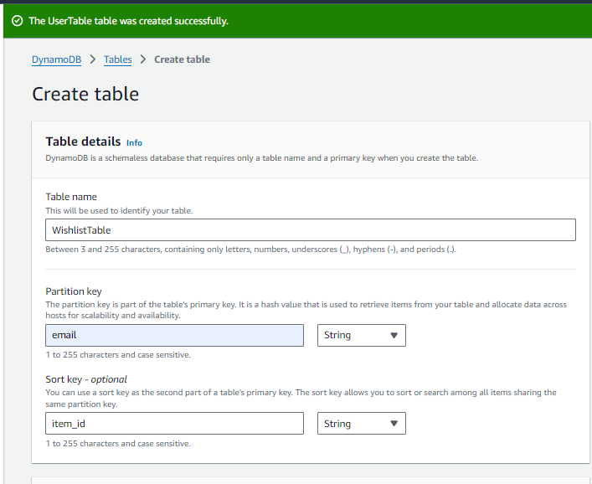



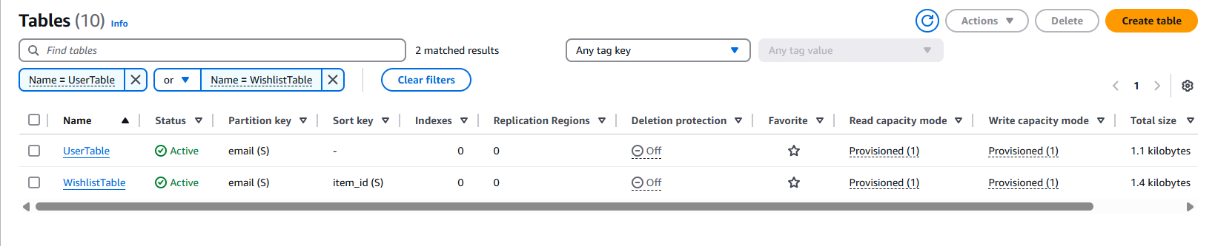

**Milestone 3:Backend Development and Application Setup**

**File Explorer:**

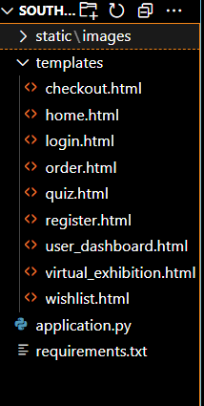

**Description:** Organize the project with HTML templates for each feature (e.g., login, wishlist, quiz, checkout) under the templates folder and manage backend logic in application.py.

* **Activity 3.1:Develop the Backend Using Flask**

**Import libraries:**

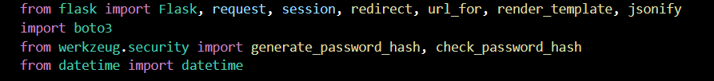

**Description:** Import essential Flask modules for web handling, Boto3 for AWS integration, Werkzeug for password hashing, and datetime for timestamp management.

**Flask App Initialization:**

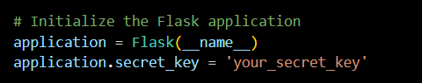

**Description:** Initialize the Flask application and set a secret key to securely manage user sessions and form data.

**Database Configuration:**

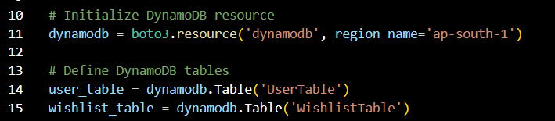

**Description:** Connect to DynamoDB using Boto3 and define references to the UserTable and WishlistTable for user and wishlist data operations.

* + **Routes for Core Functionalities:**

**Home and registration routes:**

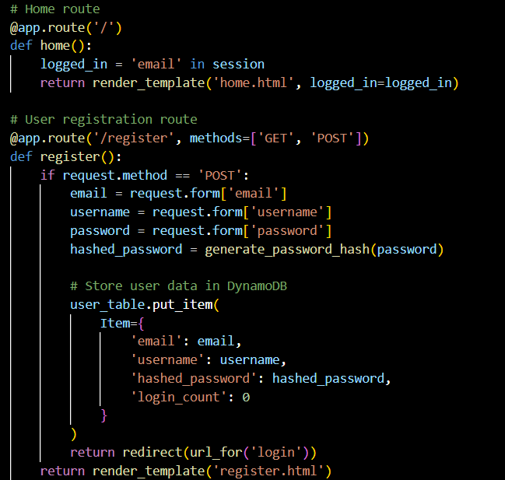

**Description:** Create the home and registration routes, where the registration route securely hashes user passwords and stores user data in DynamoDB upon form submission.

**Login routes:**

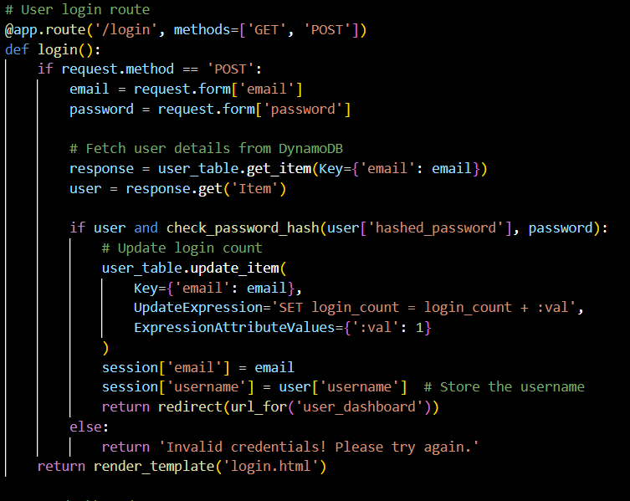

**Description:** Implement the user login route to validate credentials using DynamoDB and securely manage session data while updating the user's login count.

**User dashboard and wishlist routes:**

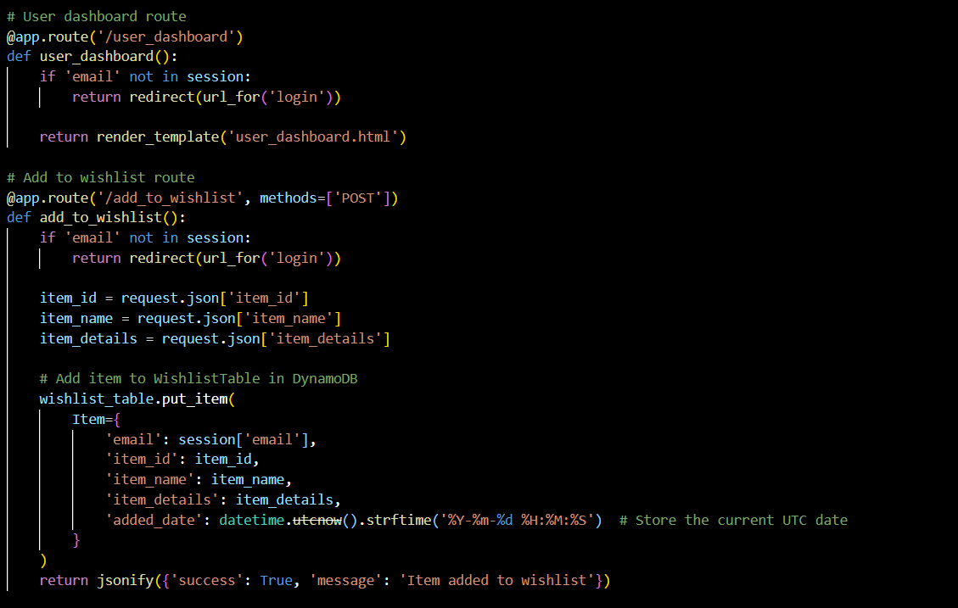

**Description:**Secure the user dashboard and implement a route to add items to the wishlist, storing them in DynamoDB with item details and a timestamp.

##### 

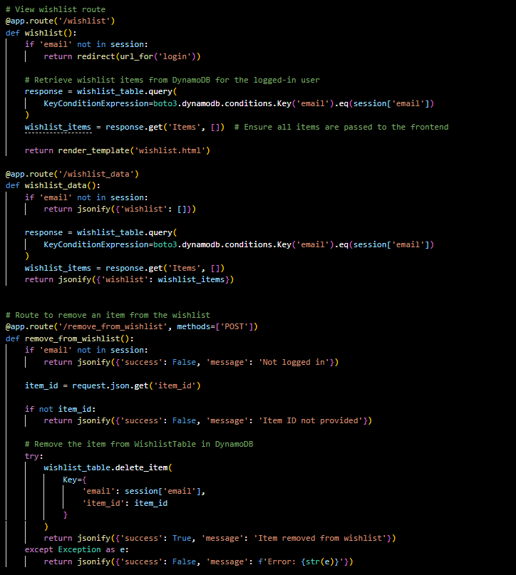

**Description:**  Build routes to display, fetch, and delete wishlist items for logged-in users by querying and modifying entries in DynamoDB using the user's email.

**Virtual exhibition, quiz and logout routes:**

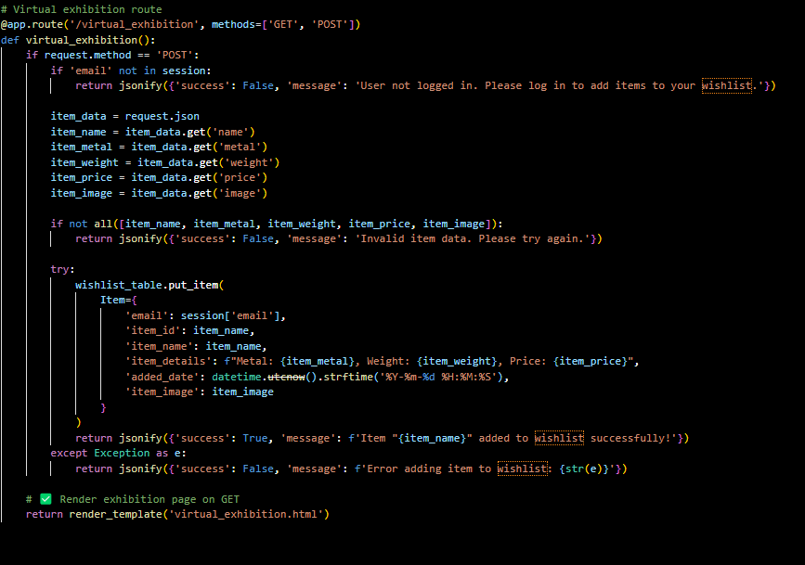

**Description:** Create a route for the virtual exhibition page where users can add detailed jewelry items to their wishlist, with proper validation and storage in DynamoDB.

**Quiz Route:**

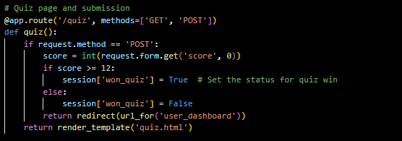

**Description:**Create a route to handle quiz submissions, storing the result in the session if the user scores 12 or more, and redirecting to the user dashboard.

**Check out route:**

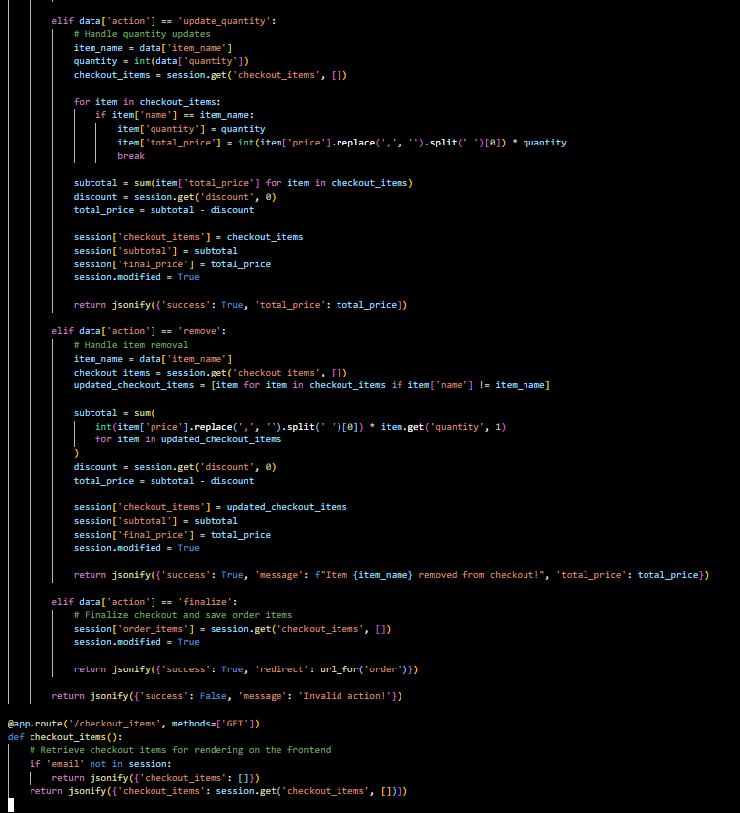

**Description:** Implement logic for updating item quantity, removing items, and finalizing orders in the shopping cart, while maintaining session-based checkout data and price calculations.

**Add to checkout route:**

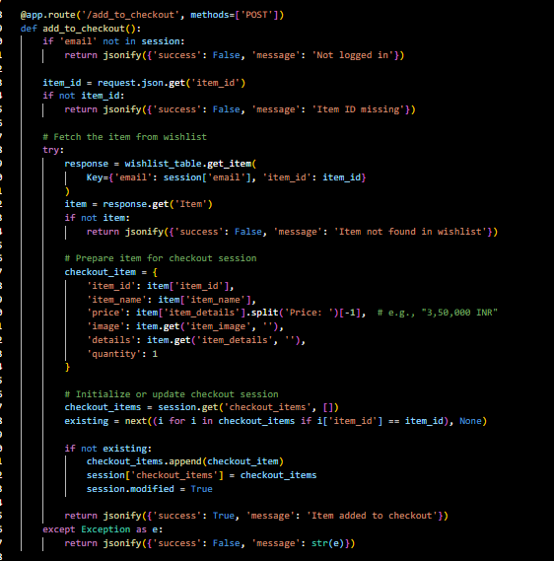

**Description:** Enable users to add wishlist items to the checkout session by retrieving item details from DynamoDB and updating the session state if the item is not already present.

**Order Route:**

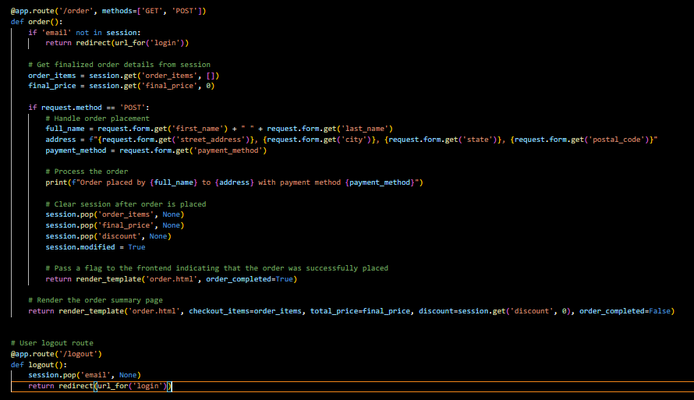

**Description:** Handle order placement by collecting customer details, processing the session-based checkout data, and clearing the session after successfully placing the order.

**Initiating Flask app:**

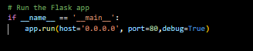

**Description:** Start the Flask application on host 0.0.0.0 and port 80 in debug mode to enable live reloads and detailed error logs during development.

Also create a requirements.txt file with used libraries .

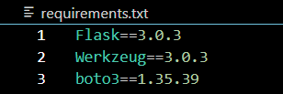

**Milestone 4: IAM Role Setup**

* **Activity 4.1: Create an IAM Role**
  + In the AWS Console, go to IAM and create a new IAM Role for EC2 to interact with DynamoDB and SNS.

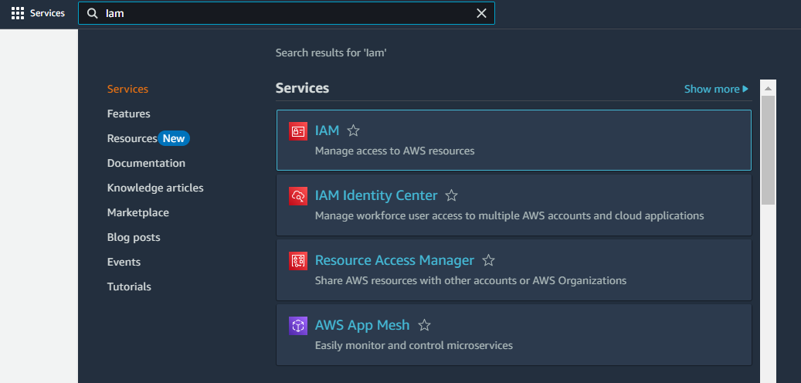

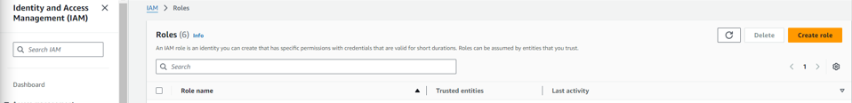

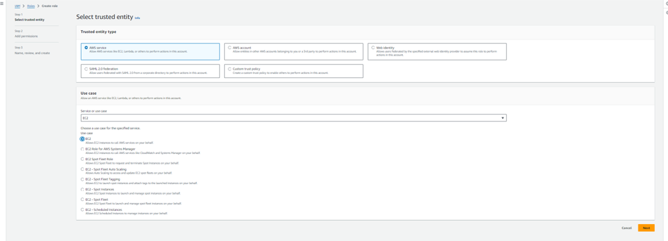

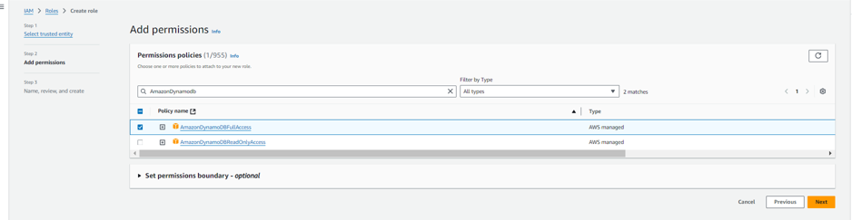

* **Activity 4.2: Attach Policies.**

Attach the following policies to the role:

* AmazonDynamoDBFullAccess: Allows EC2 to perform read/write operations on DynamoDB.
* AmazonSNSFullAccess: Grants EC2 the ability to send notifications via SNS.

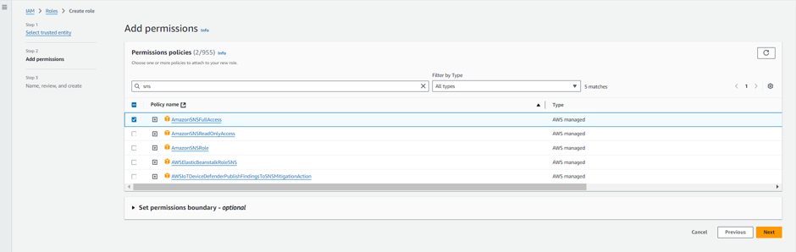

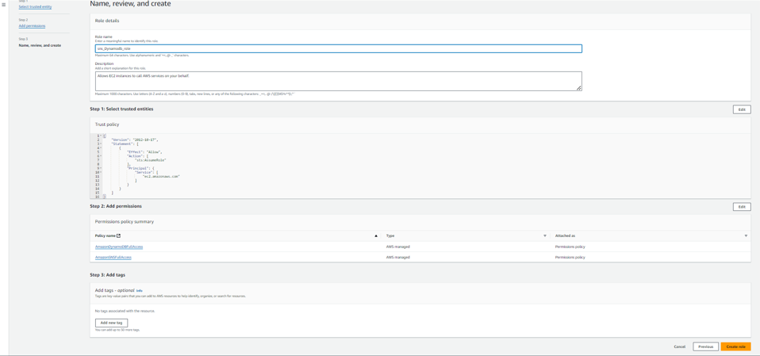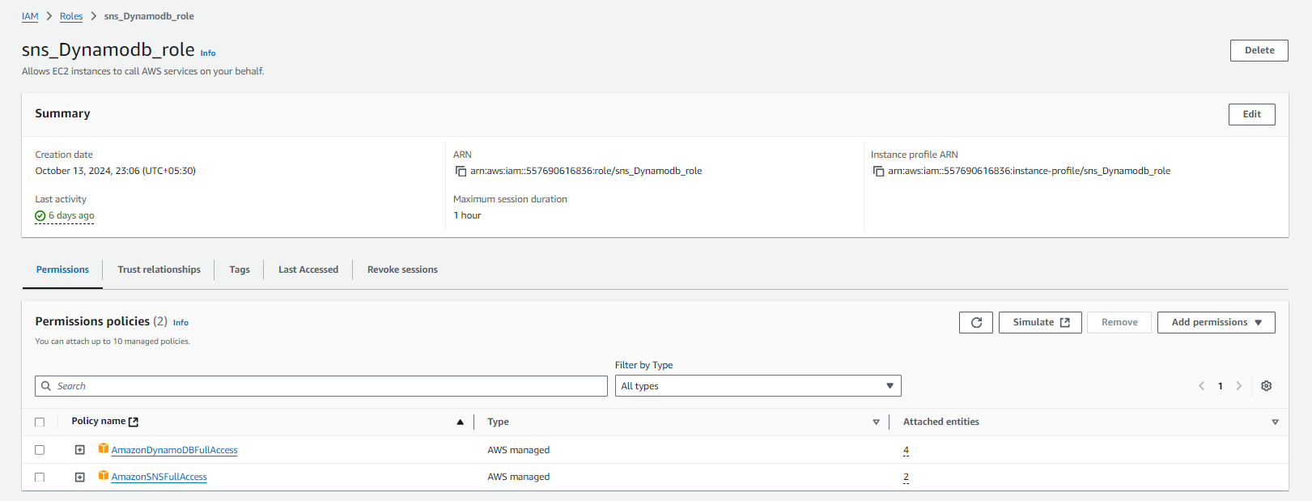

**Milestone 5: EC2 Instance Setup**

* **Note: Load your Flask app and Html files into GitHub repository.**

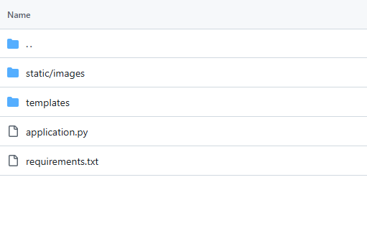

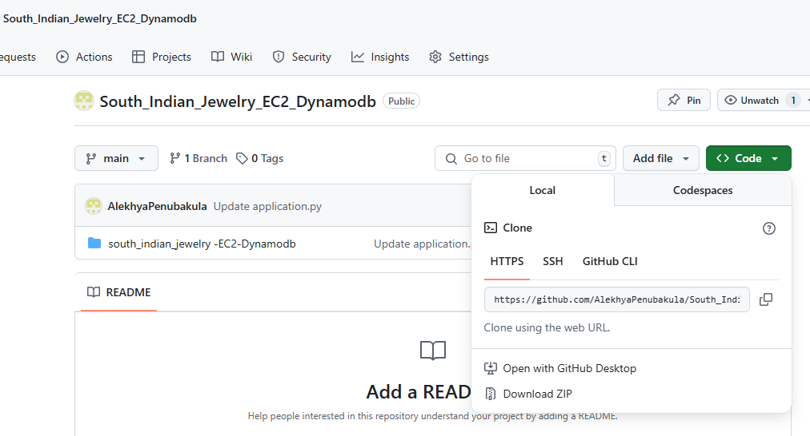

* **Activity 6.1: Launch an EC2 instance to host the Flask application.**
* **Launch EC2 Instance**
  + In the AWS Console, navigate to EC2 and launch a new instance.

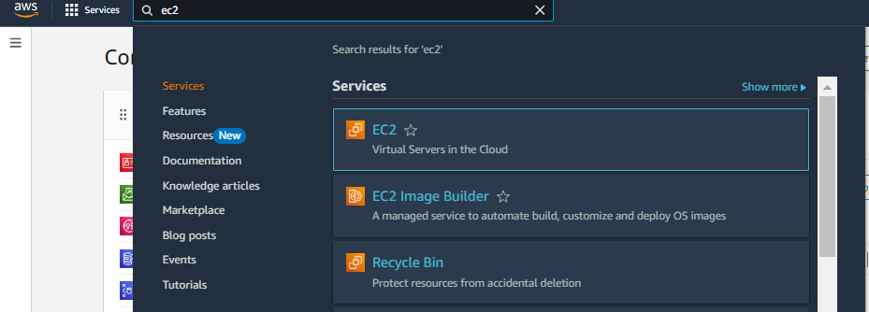

* Click on Launch instance to launch EC2 instance

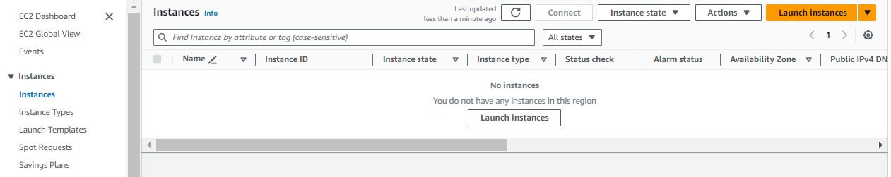

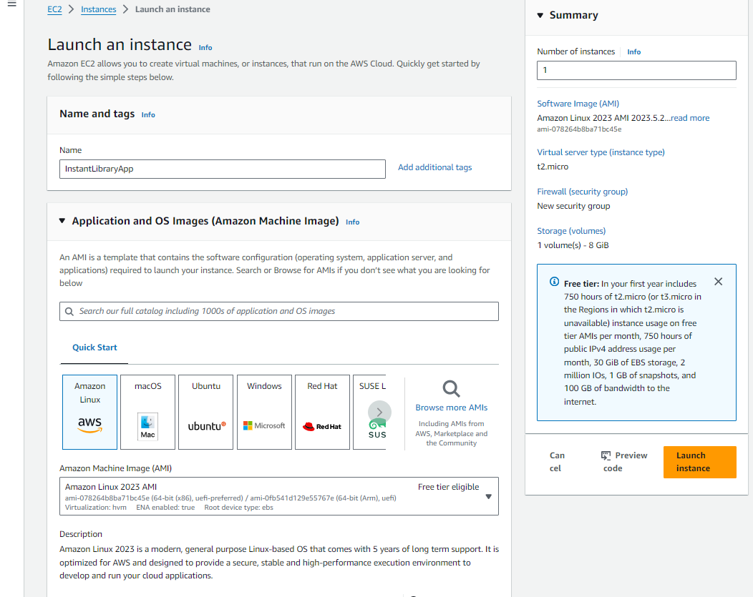

* Choose Amazon Linux 2 or Ubuntu as the AMI and t2.micro as the instance type (free-tier eligible).

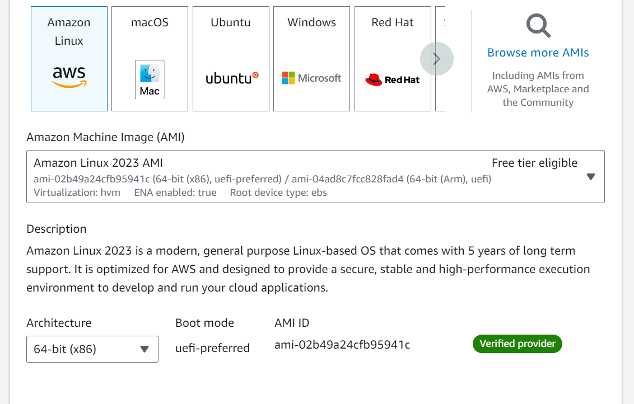

* Create and download the key pair for Server access.

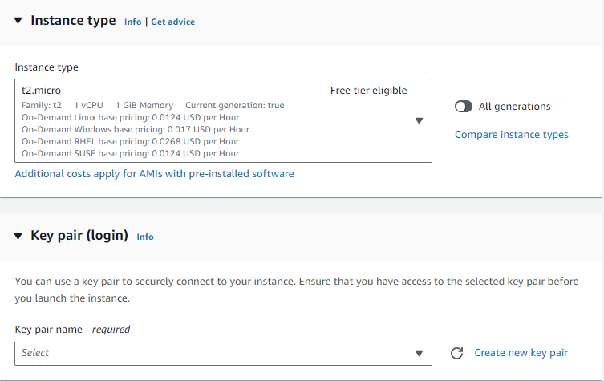

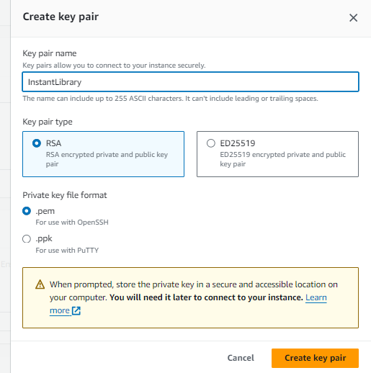

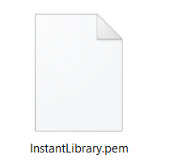

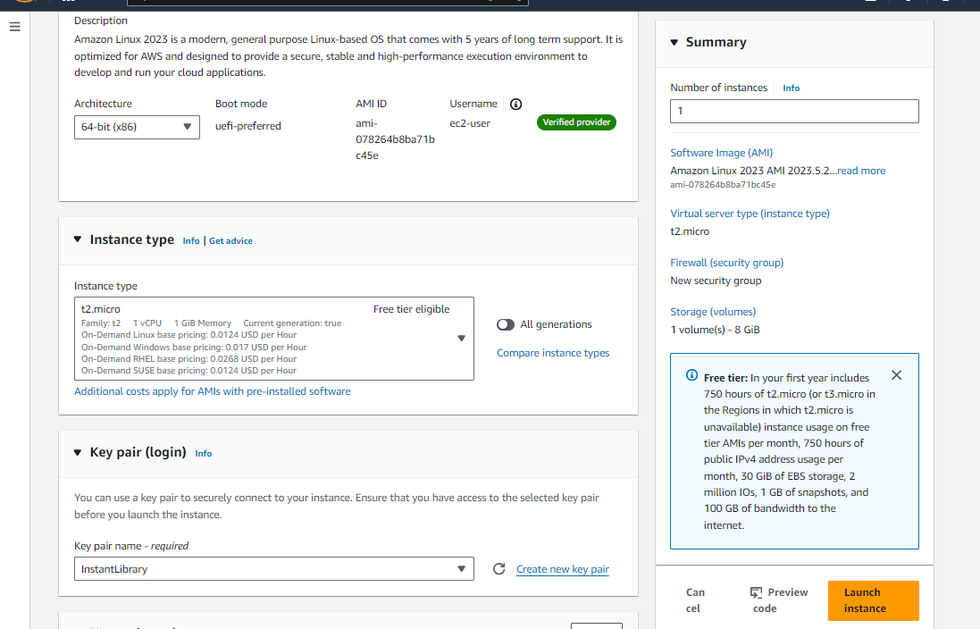

* **Activity 6.2:Configure security groups for HTTP, and SSH access.**

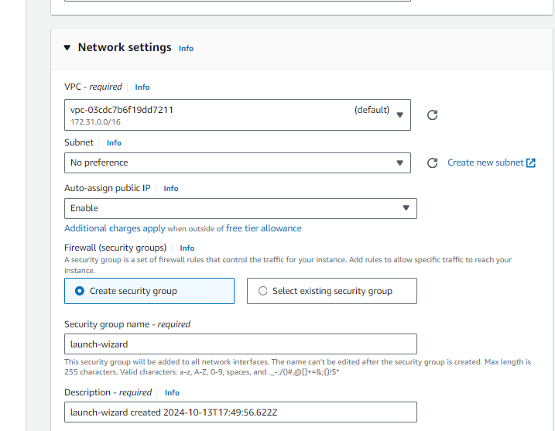

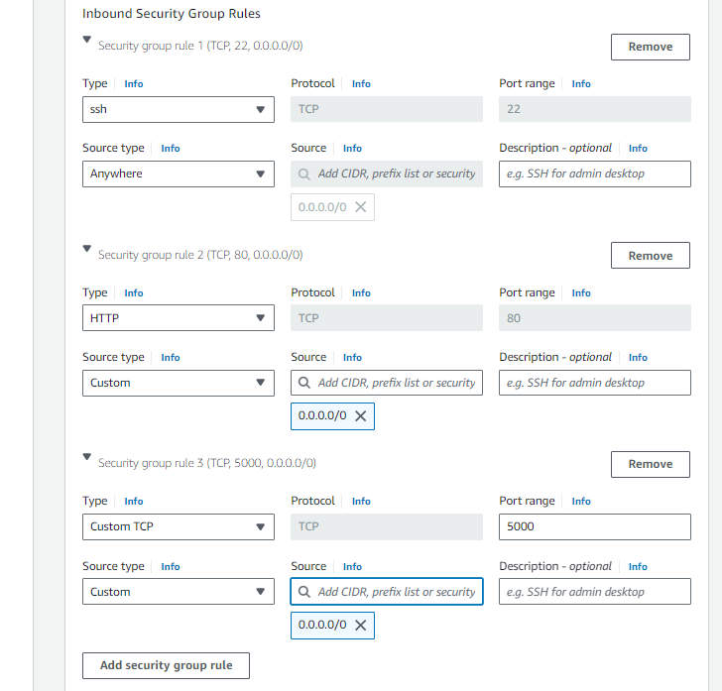

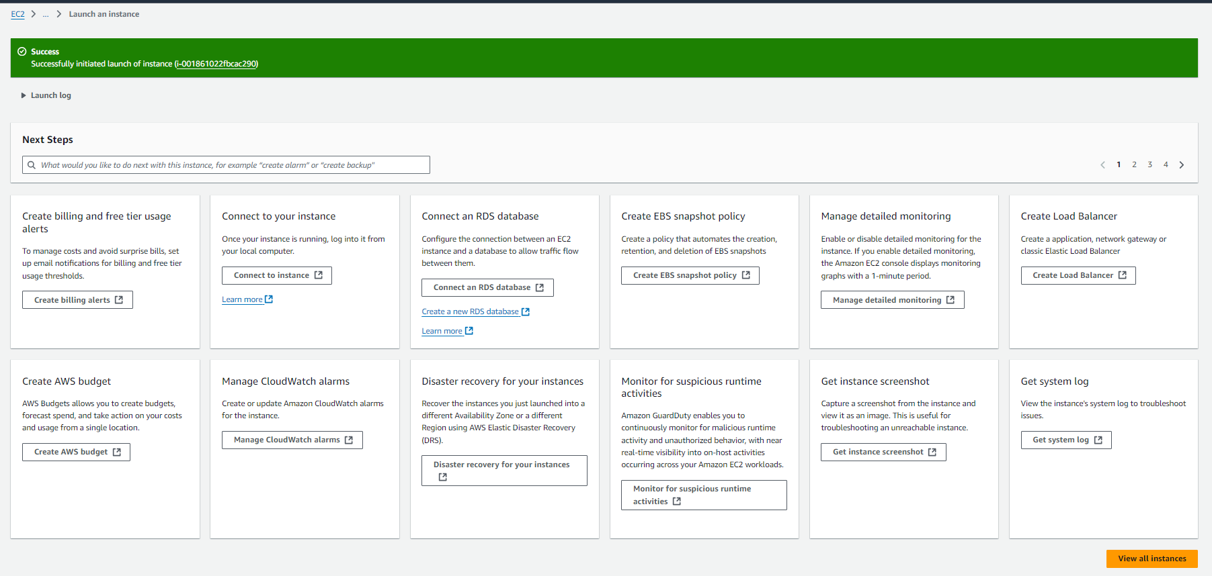

* To connect to EC2 using **EC2 Instance Connect**, start by ensuring that an **IAM role** is attached to your EC2 instance. You can do this by selecting your instance, clicking on **Actions**, then navigating to **Security** and selecting **Modify IAM Role** to attach the appropriate role. After the IAM role is connected, navigate to the **EC2** section in the **AWS Management Console**. Select the **EC2 instance** you wish to connect to. At the top of the **EC2 Dashboard**, click the **Connect** button. From the connection methods presented, choose **EC2 Instance Connect**. Finally, click **Connect** again, and a new browser-based terminal will open, allowing you to access your EC2 instance directly from your browser.



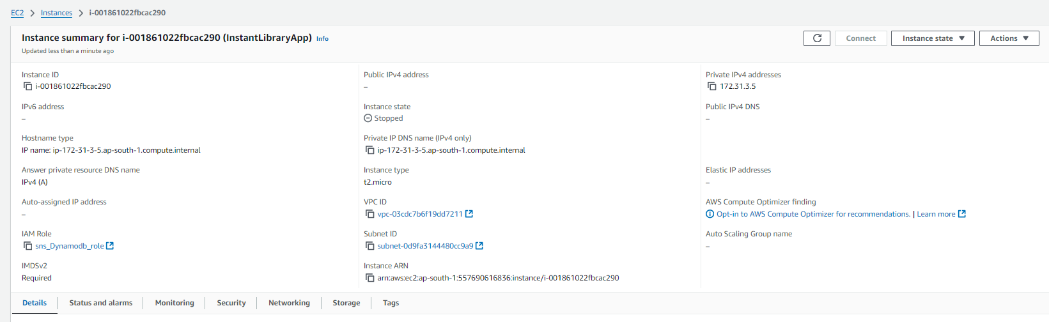

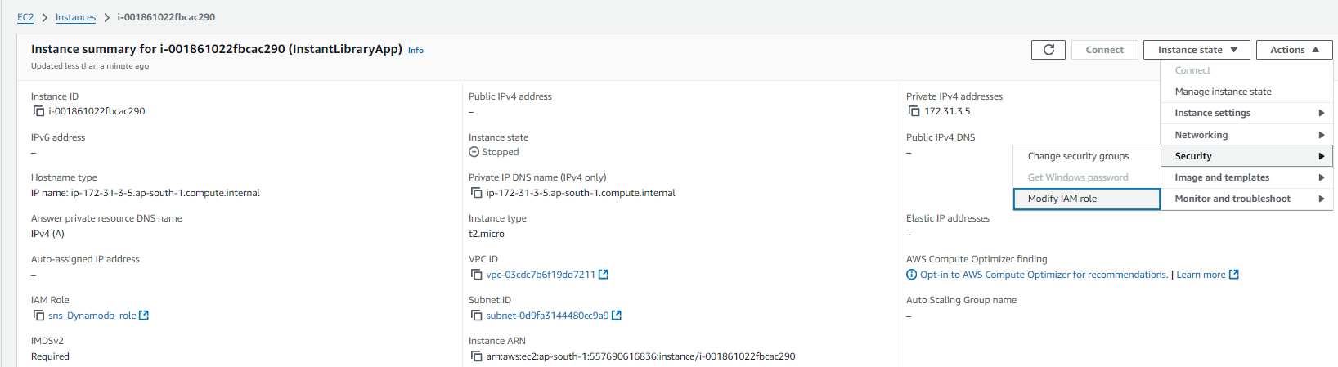

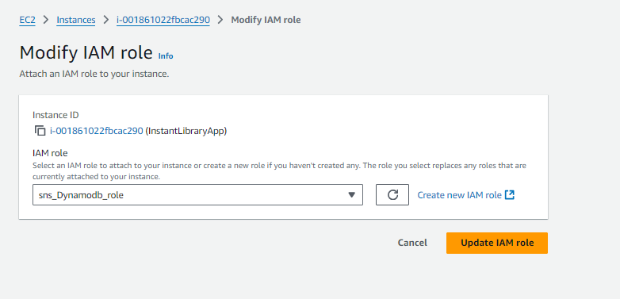

* Now connect the EC2 with the files

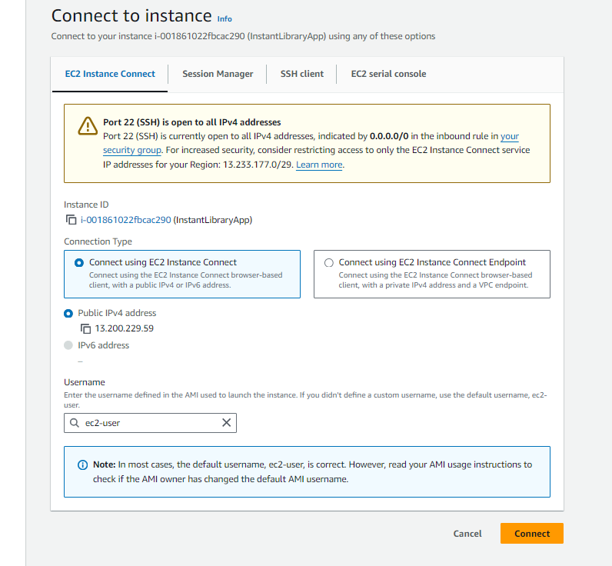

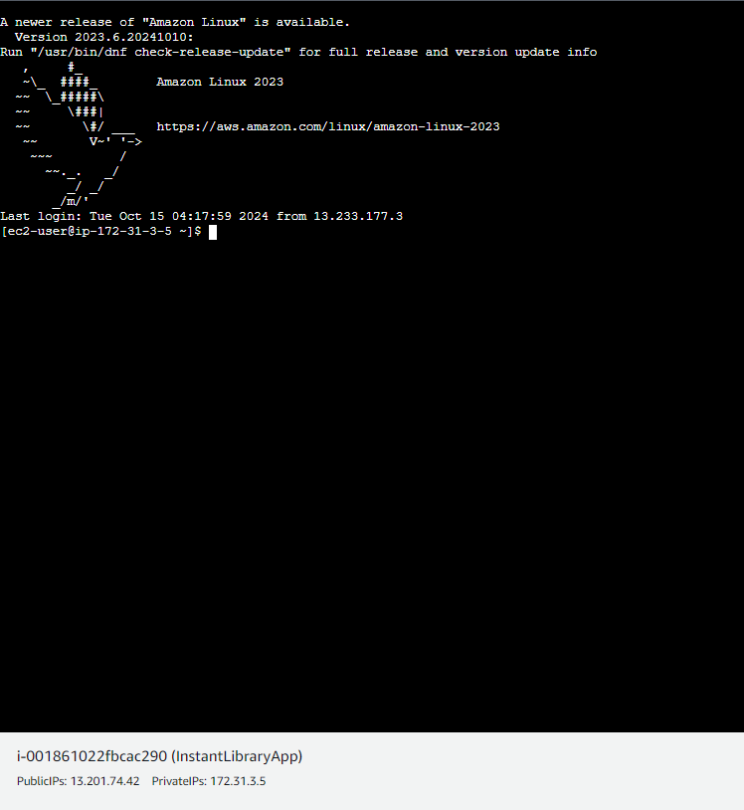

**Milestone 7: Deployment on EC2**

**Activity 7.1: Install Software on the EC2 Instance**

Install Python3, Flask, and Git:

On Amazon Linux 2:

sudo yum update -y

sudo yum install python3 git

sudo pip3 install flask boto3

Verify Installations:

flask --version

git --version

**Activity 7.2:Clone Your Flask Project from GitHub**

**Clone your project repository from GitHub into the EC2 instance using Git.**

Run: ‘git clone <https://github.com/your-github-username/your-repository-name.git>’

Note: change your-github-username and your-repository-name with your credentials

here: ‘https://github.com/AlekhyaPenubakula/South_Indian_Jewelry_EC2_Dynamodb.git’

* This will download your project to the EC2 instance.

**To navigate to the project directory, run the following command:**

cd <your files path>

**Once inside the project directory, configure and run the Flask application by executing the following command with elevated privileges:**

**Run the Flask Application**

Sudo python3 application.py

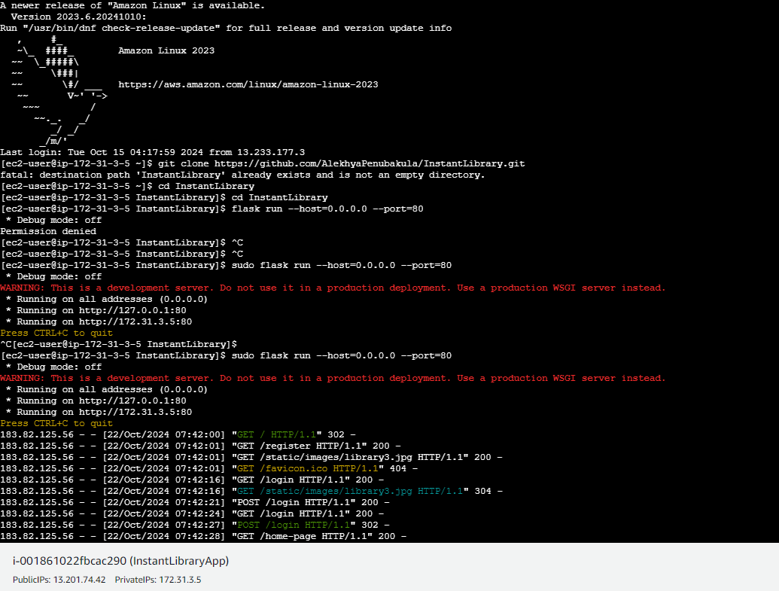

**Verify the Flask app is running**:

http://your-ec2-public-ip

* + Run the Flask app on the EC2 instance

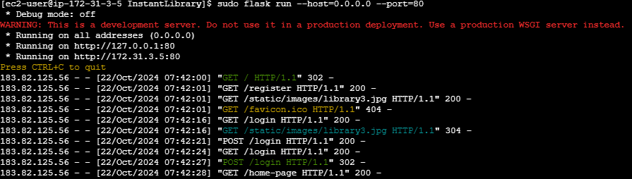

**Access the website through:  
 PublicIPs:** <https://13.201.74.42>

* **Activity 6.2: Test the Application  
    
  Home Page:**

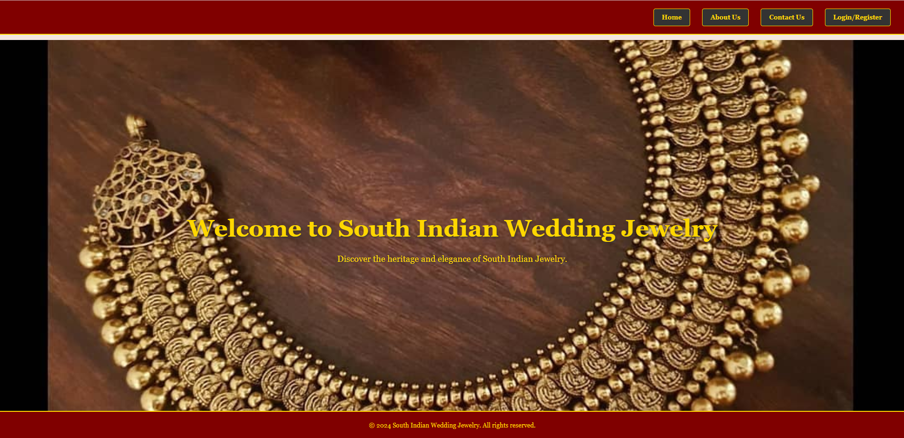

**About us Page:**

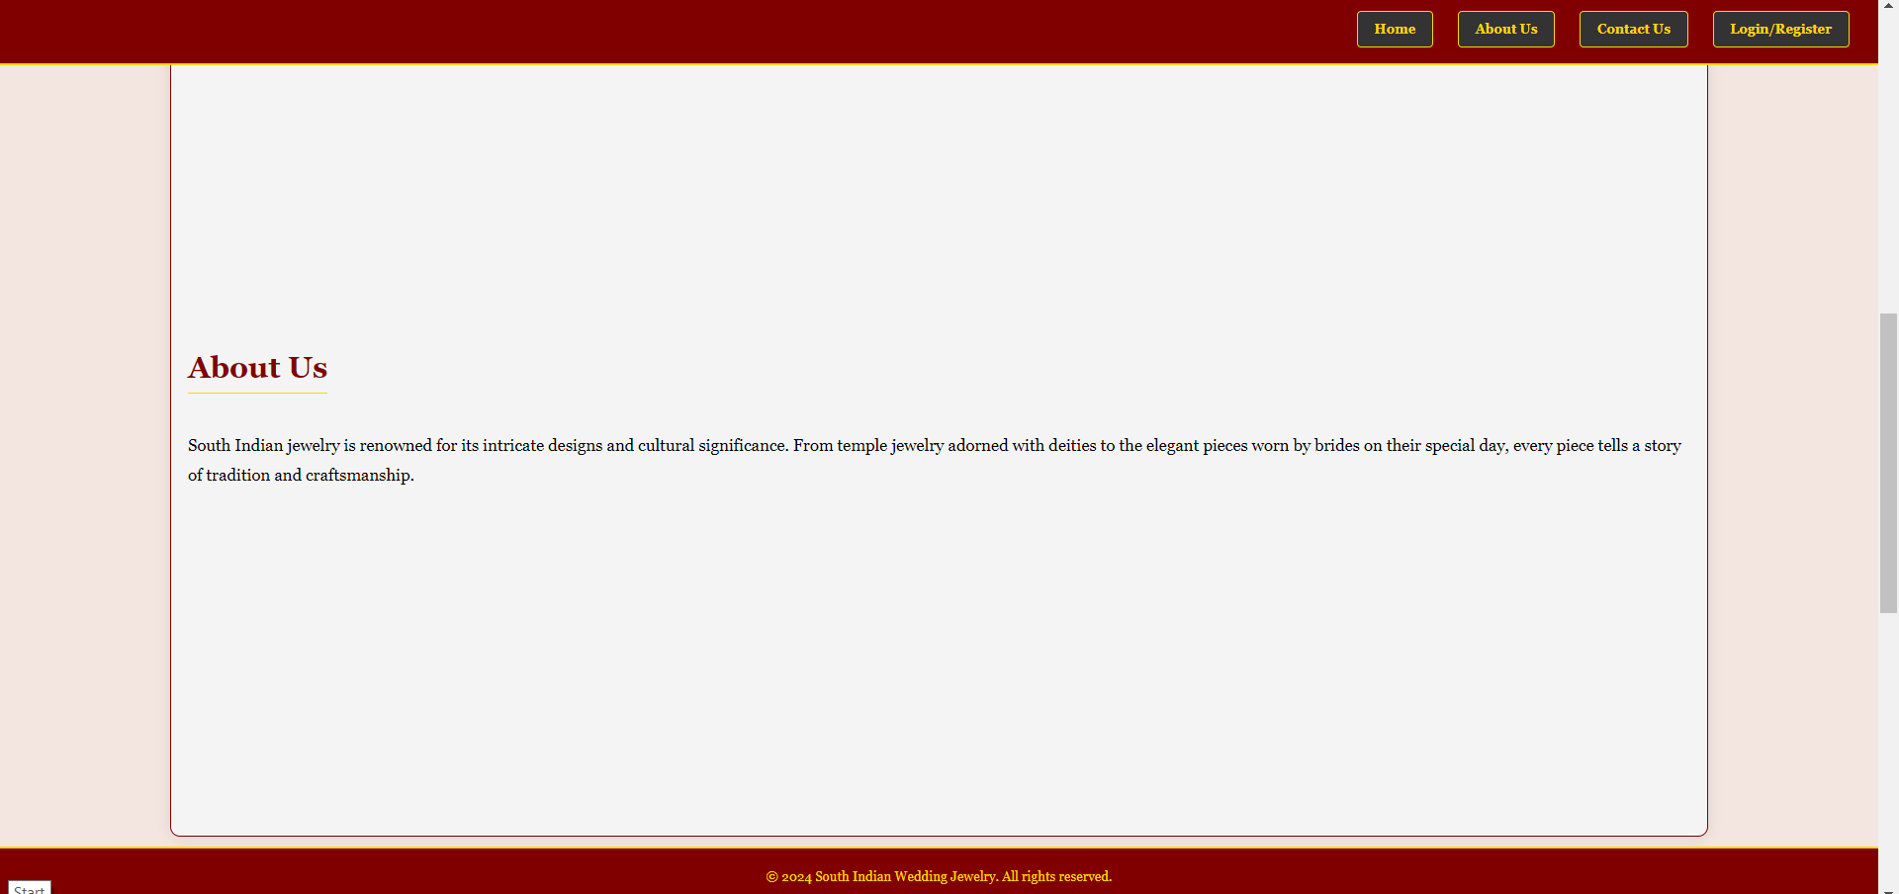

**Contact us page:**

**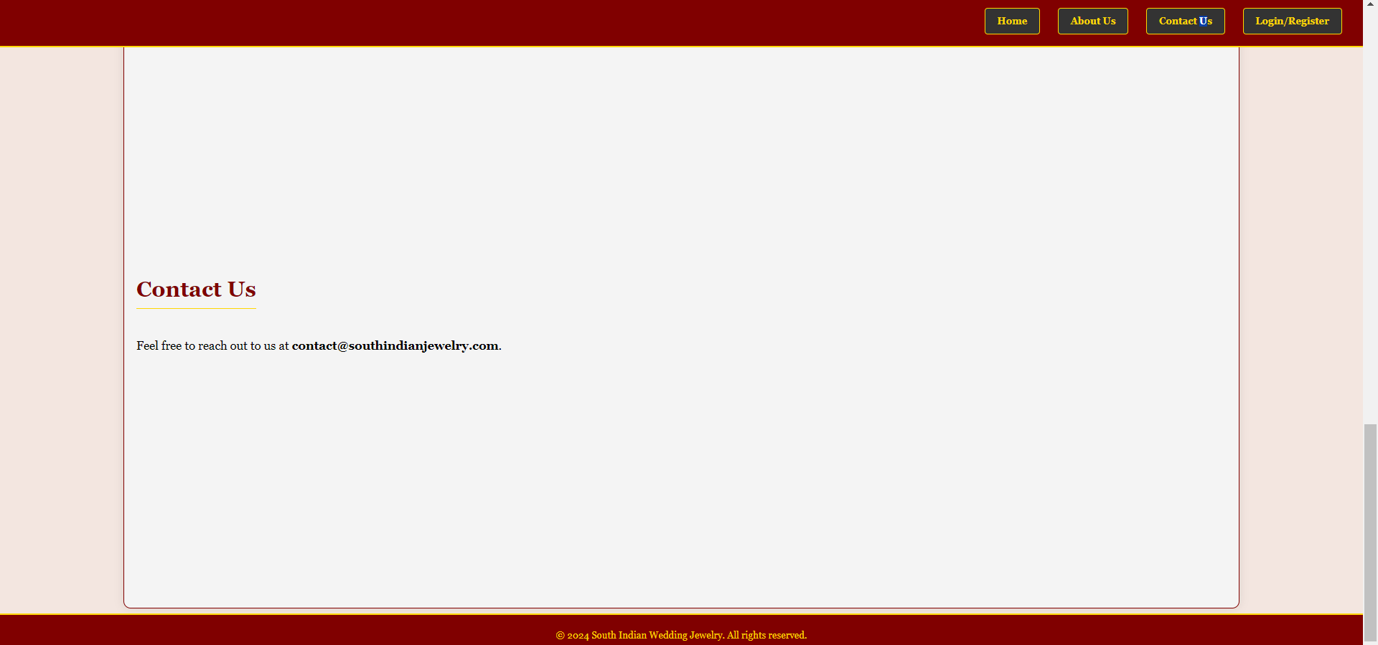  
  
Registration Page:**

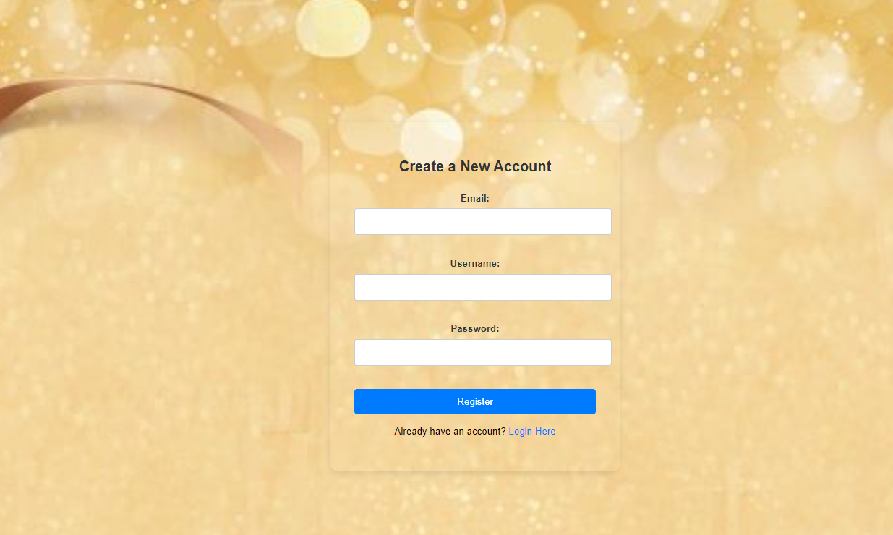

**Login Page:**

**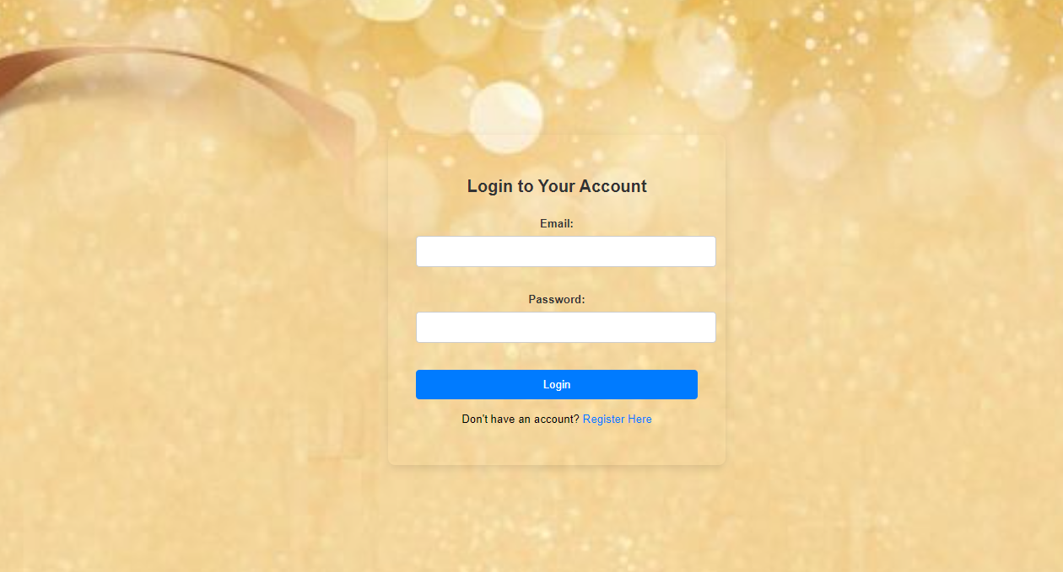  
  
User Dashboard Page:**

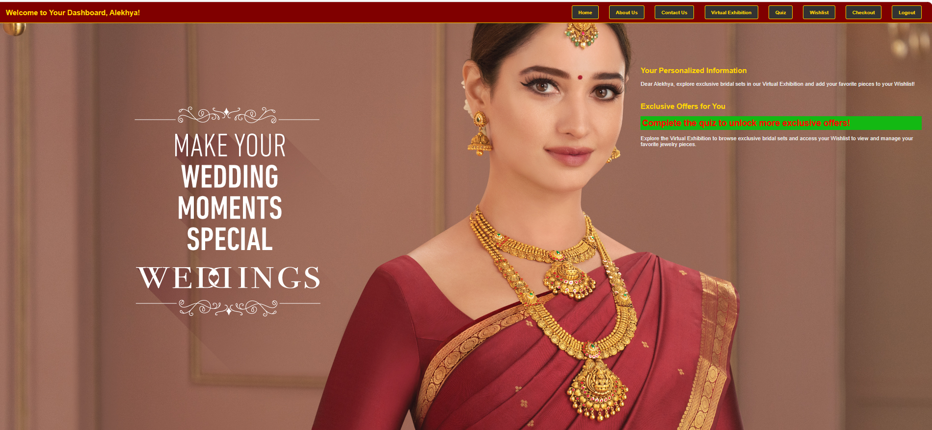

**Home Page(after login):**



Virtual exhibition page:

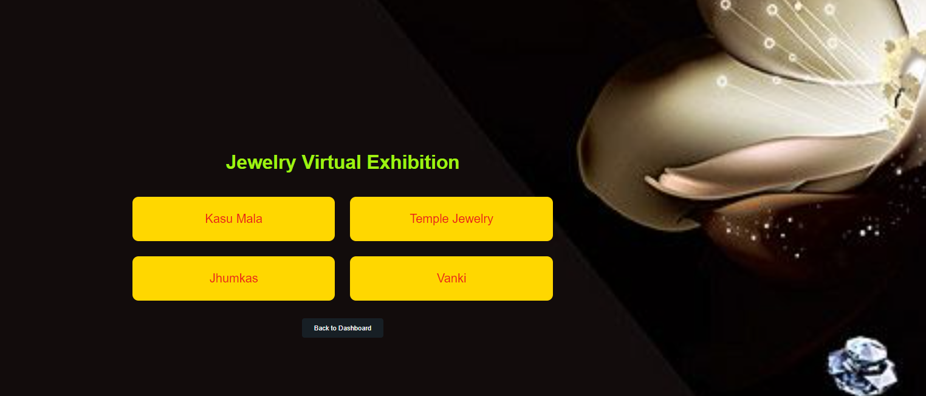

Kasu Mala page:

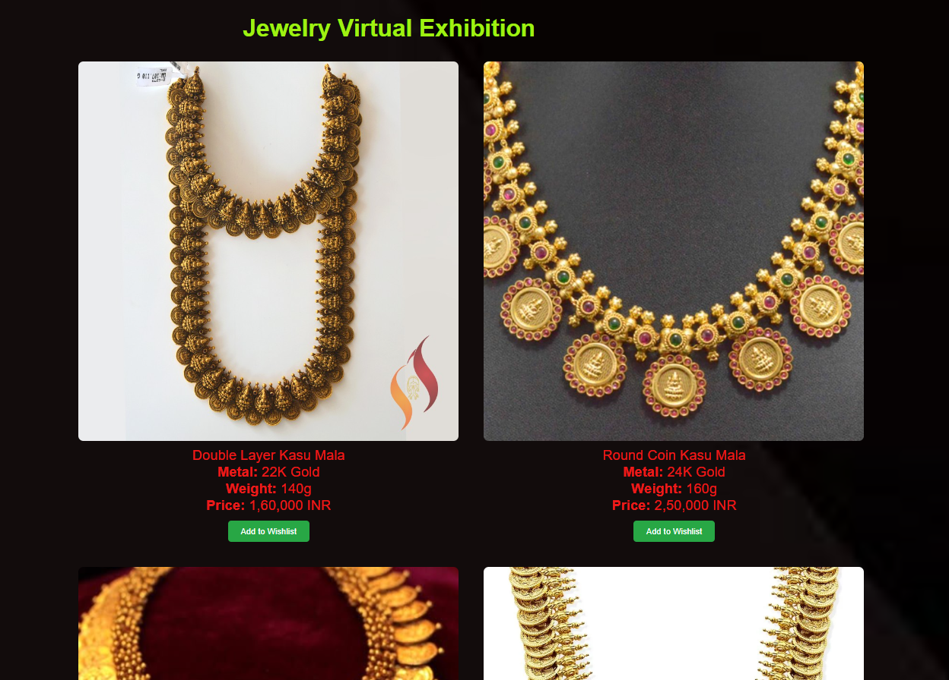

Temple necklace page:



Jhumkas Page:

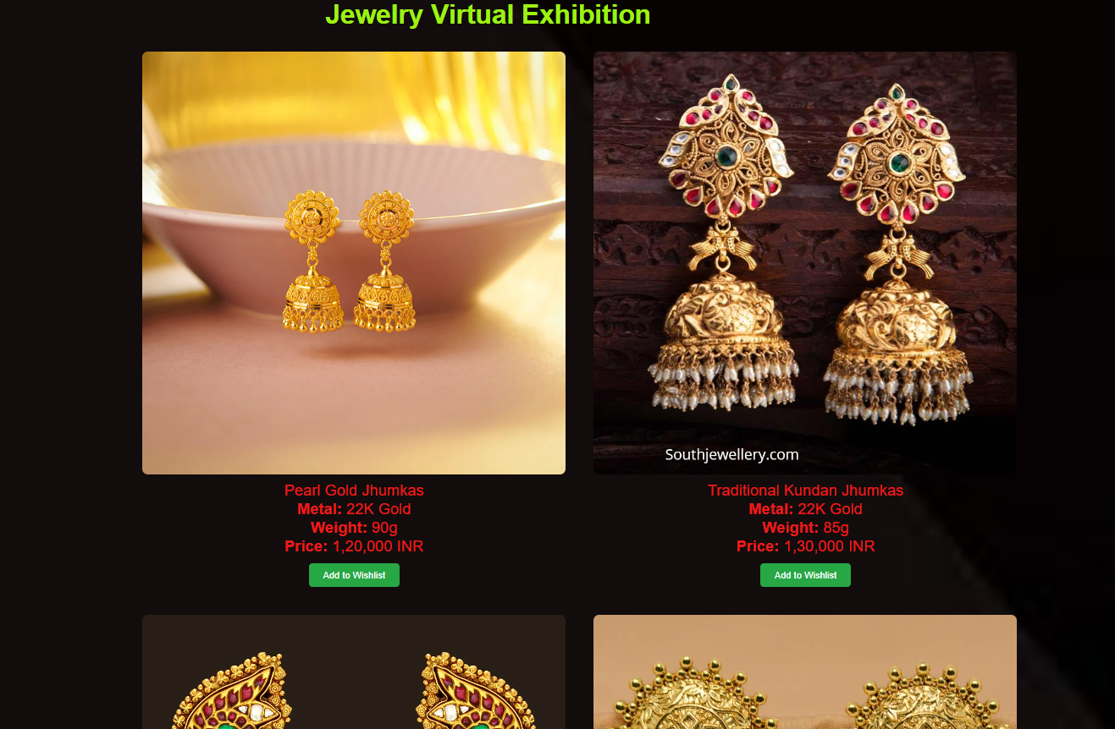

Vanki page:

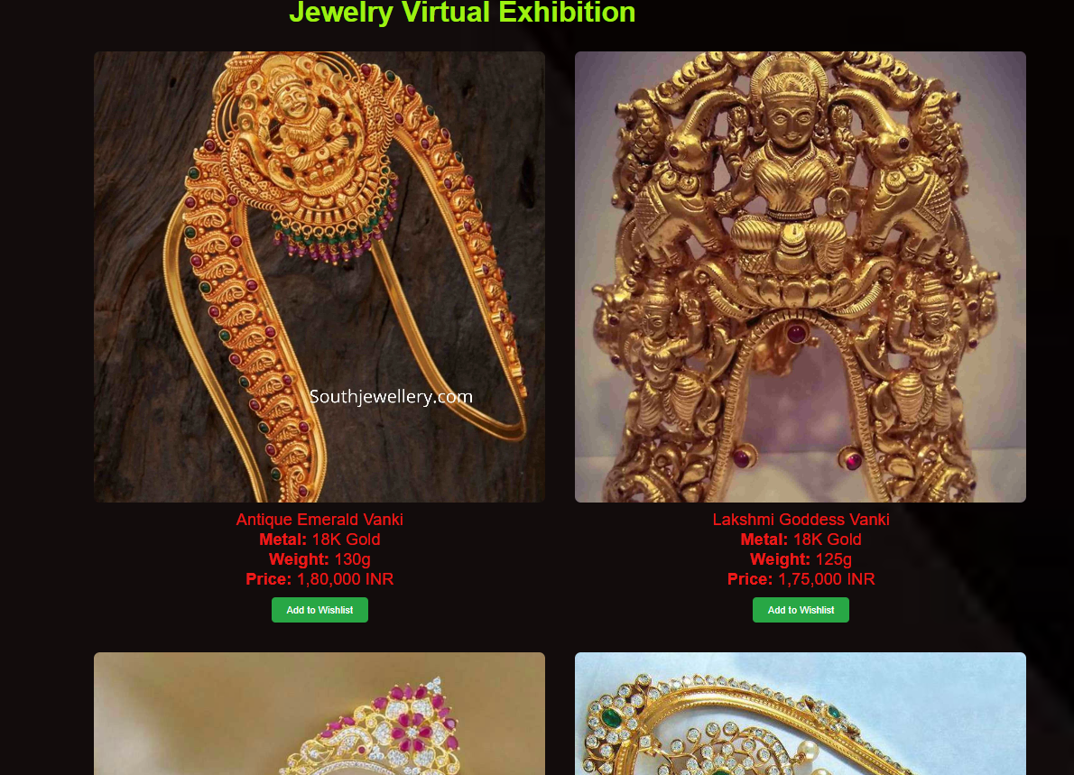

Wishlist Page:

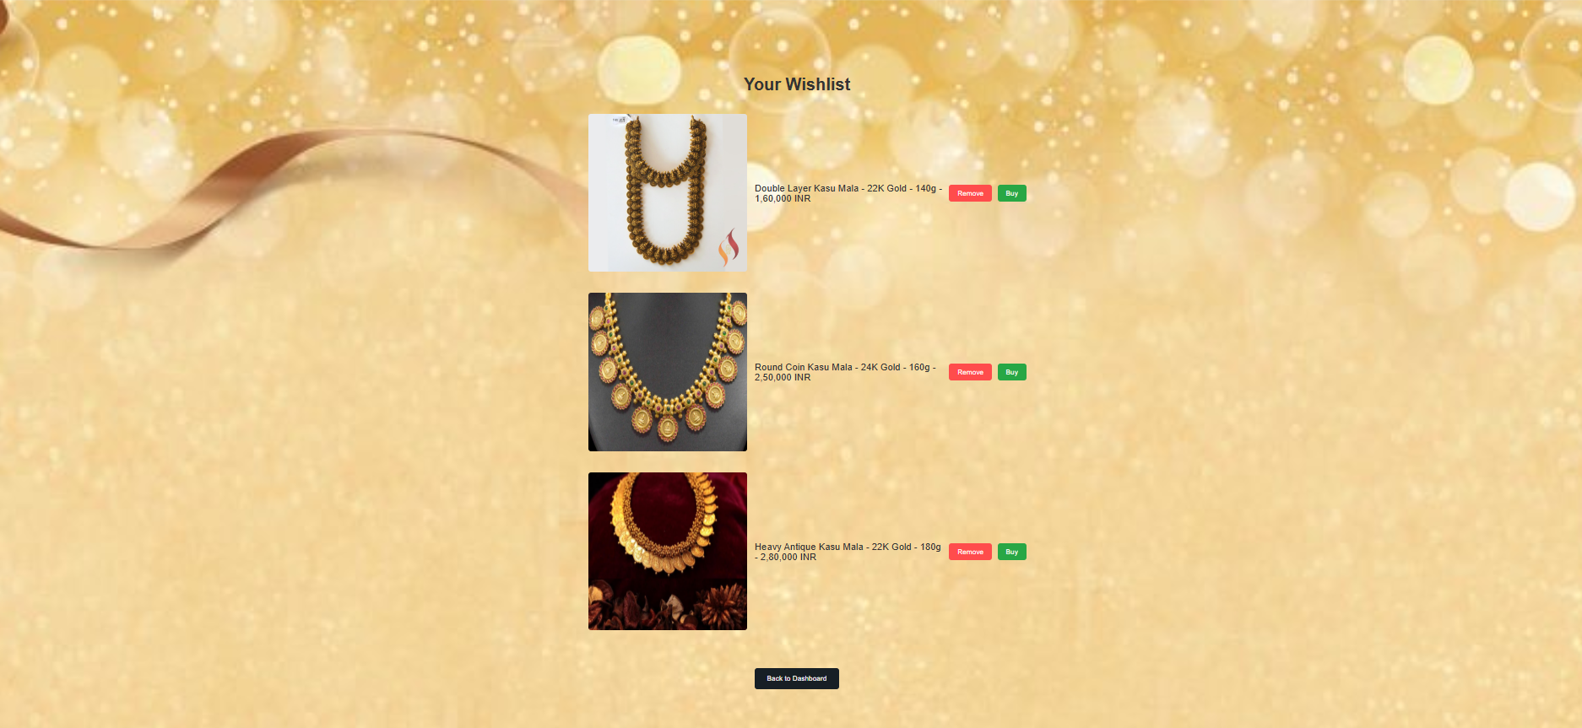

Quiz Page:

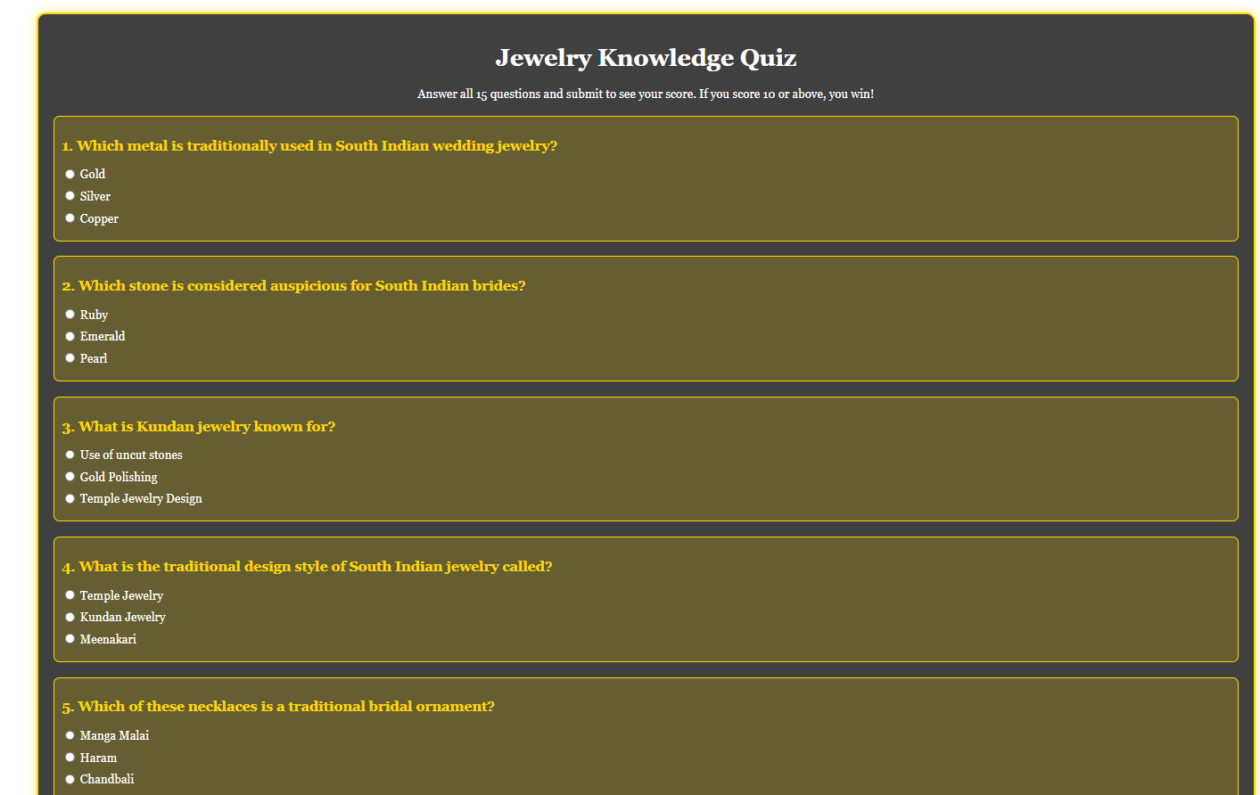

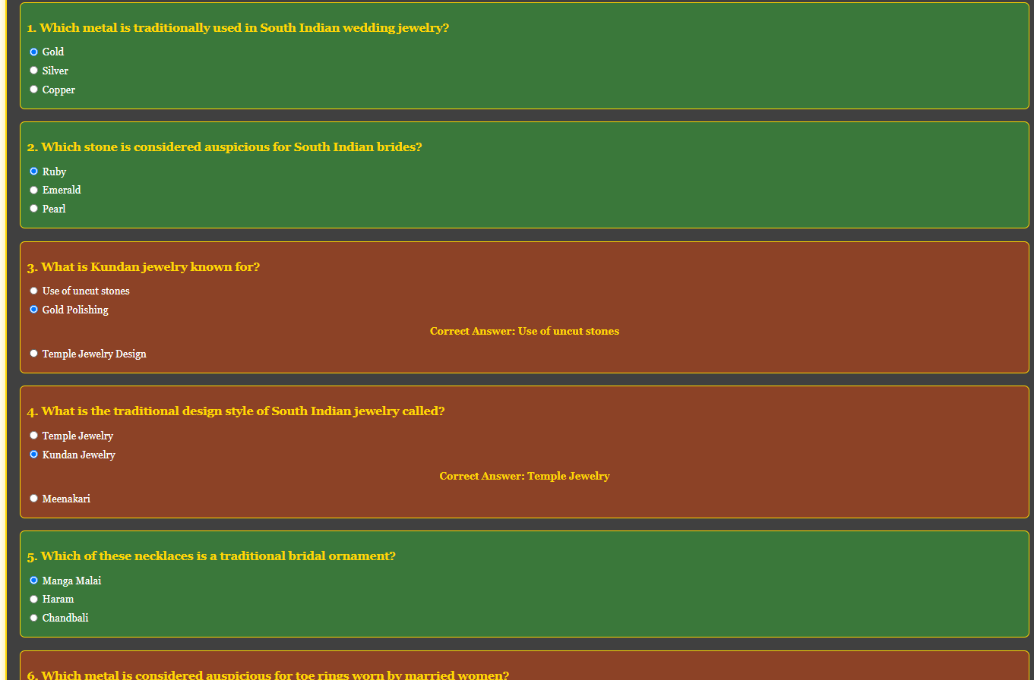

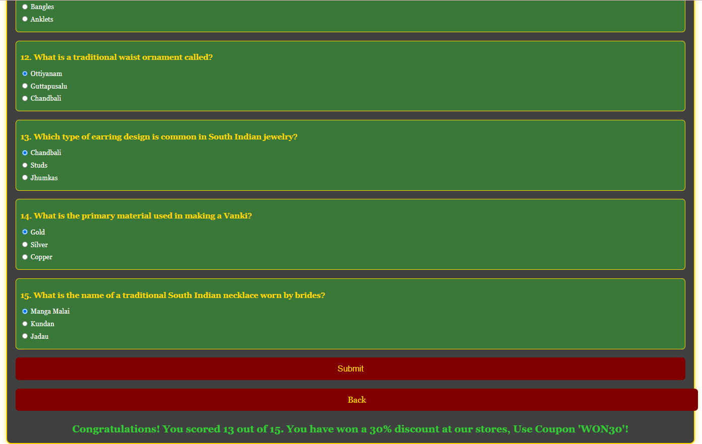  
  
User dashboard (after won in quiz):

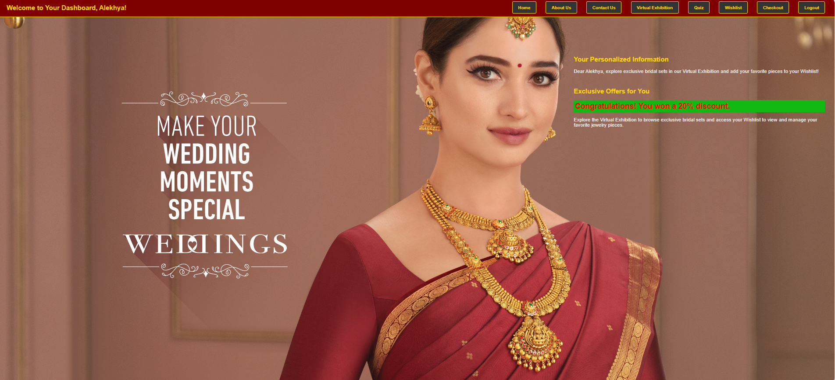

Checkout Page:

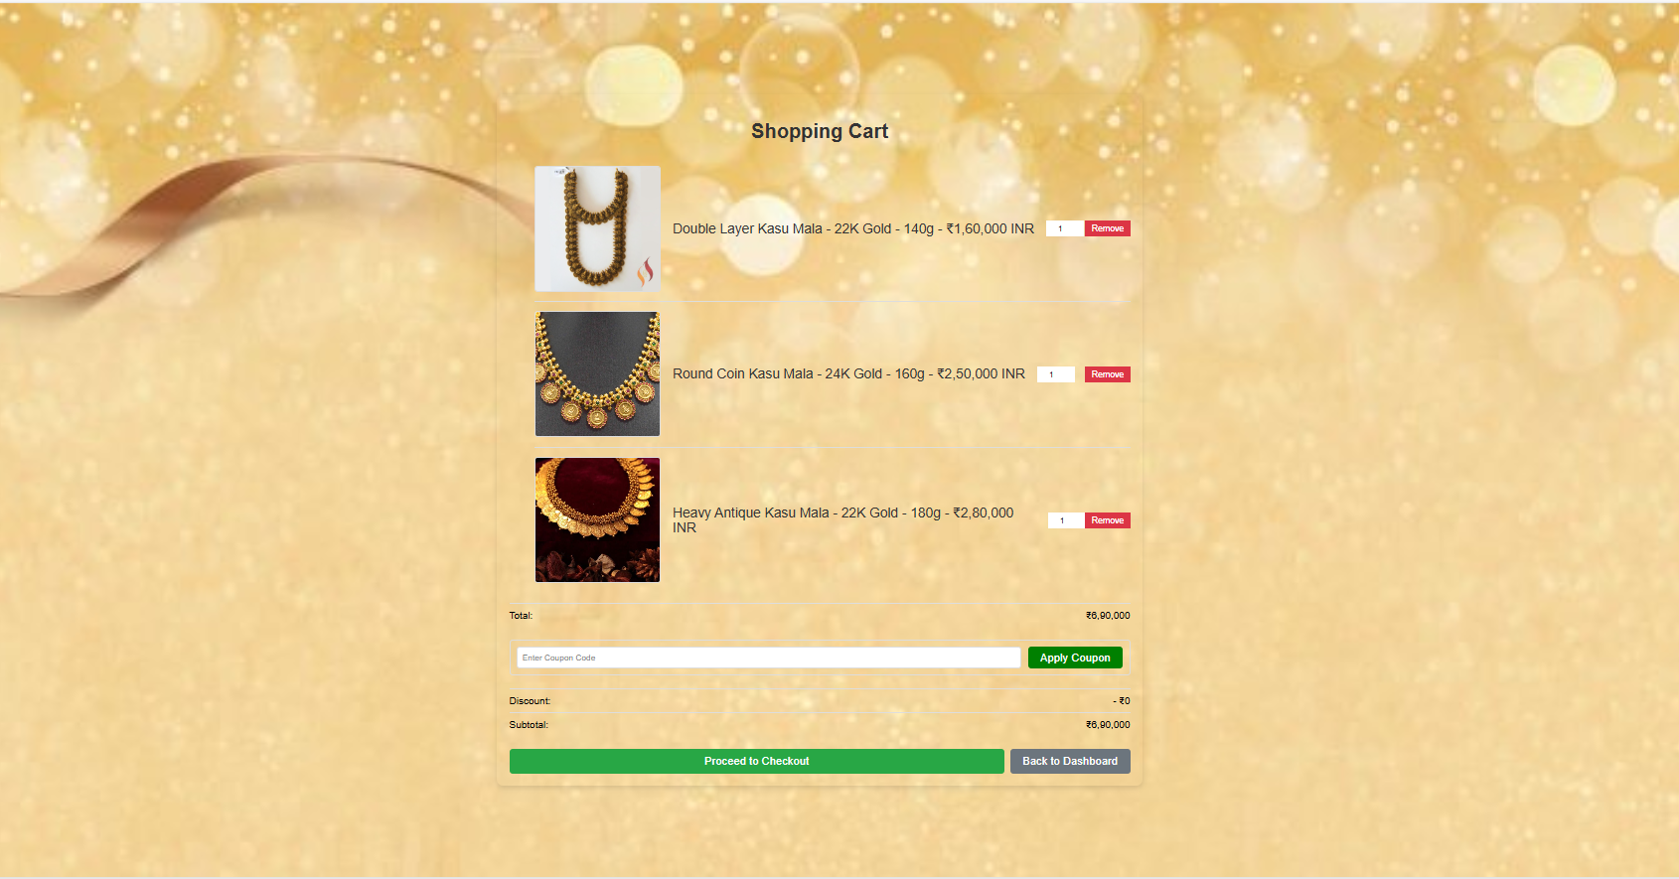

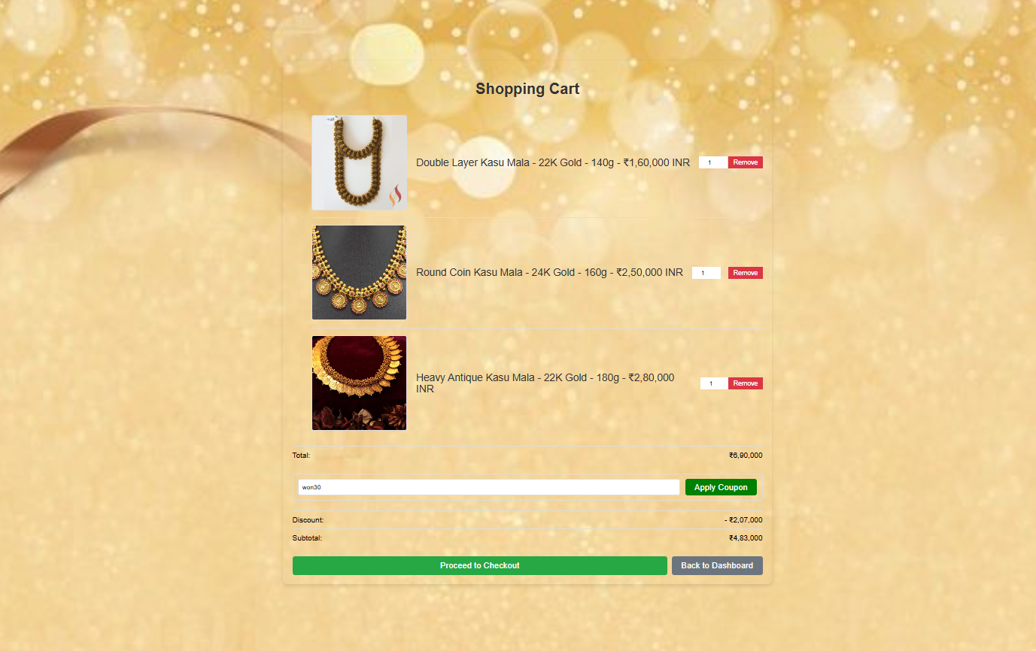

Payment Page:

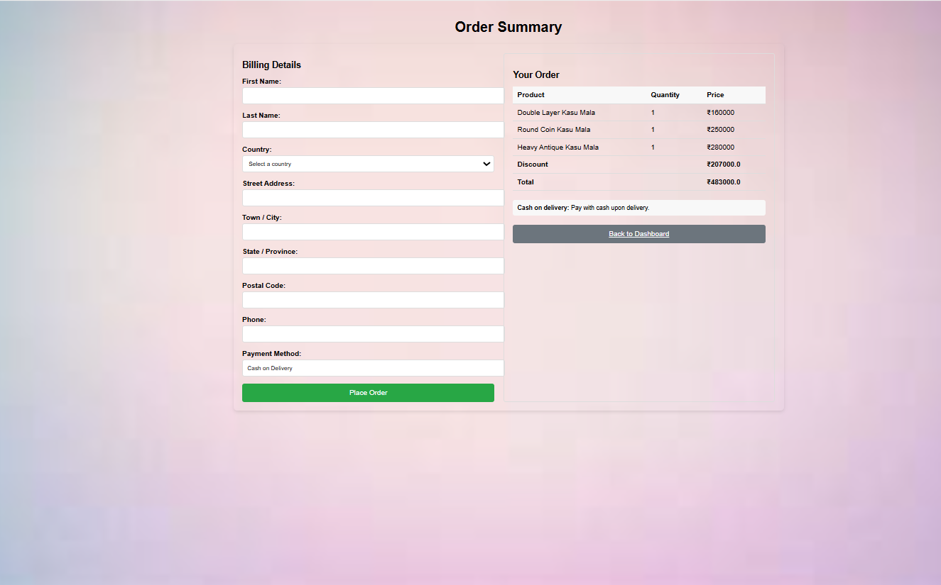



**Milestone 7:Testing and Final Deployment**

* **Activity 7.1: Data Storage**
  + Go to Dynamodb -> Explore Items and find UserTable and Wishlist Table

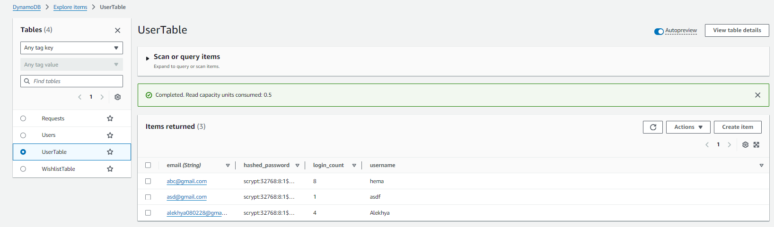

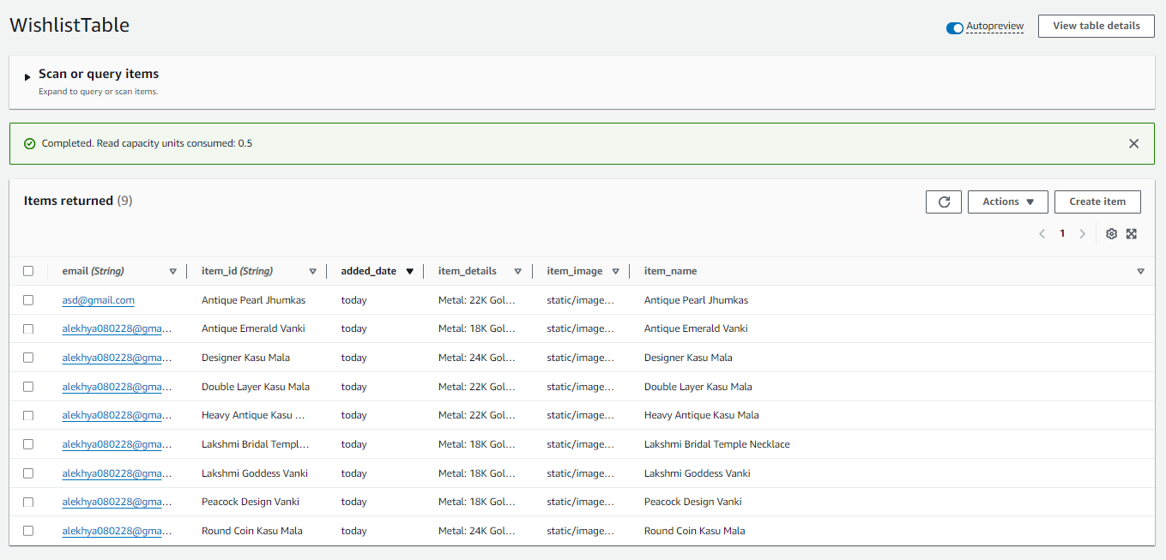

**Conclusion:**

The Sri Anandha Jewelers Virtual Jewelry Exhibition website provides an engaging and modern platform for showcasing South Indian wedding jewelry. By using Flask for backend development, AWS EC2 for hosting, and DynamoDB for managing user data such as wishlists and quiz results, the website delivers a seamless and interactive user experience.

This solution allows users to explore jewelry collections, add items to their wishlists, and participate in a quiz to win discount coupons and adding them in shopping cart and ordering them. The architecture ensures scalability, reliability, and ease of management, providing Sri Anandha Jewelers with an efficient way to promote their jewelry collection while offering users an informative and personalized shopping experience. The deployment on AWS guarantees high availability and smooth operation, enabling the brand to reach a wider audience through its virtual platform.